**Work Breakdown Structure** 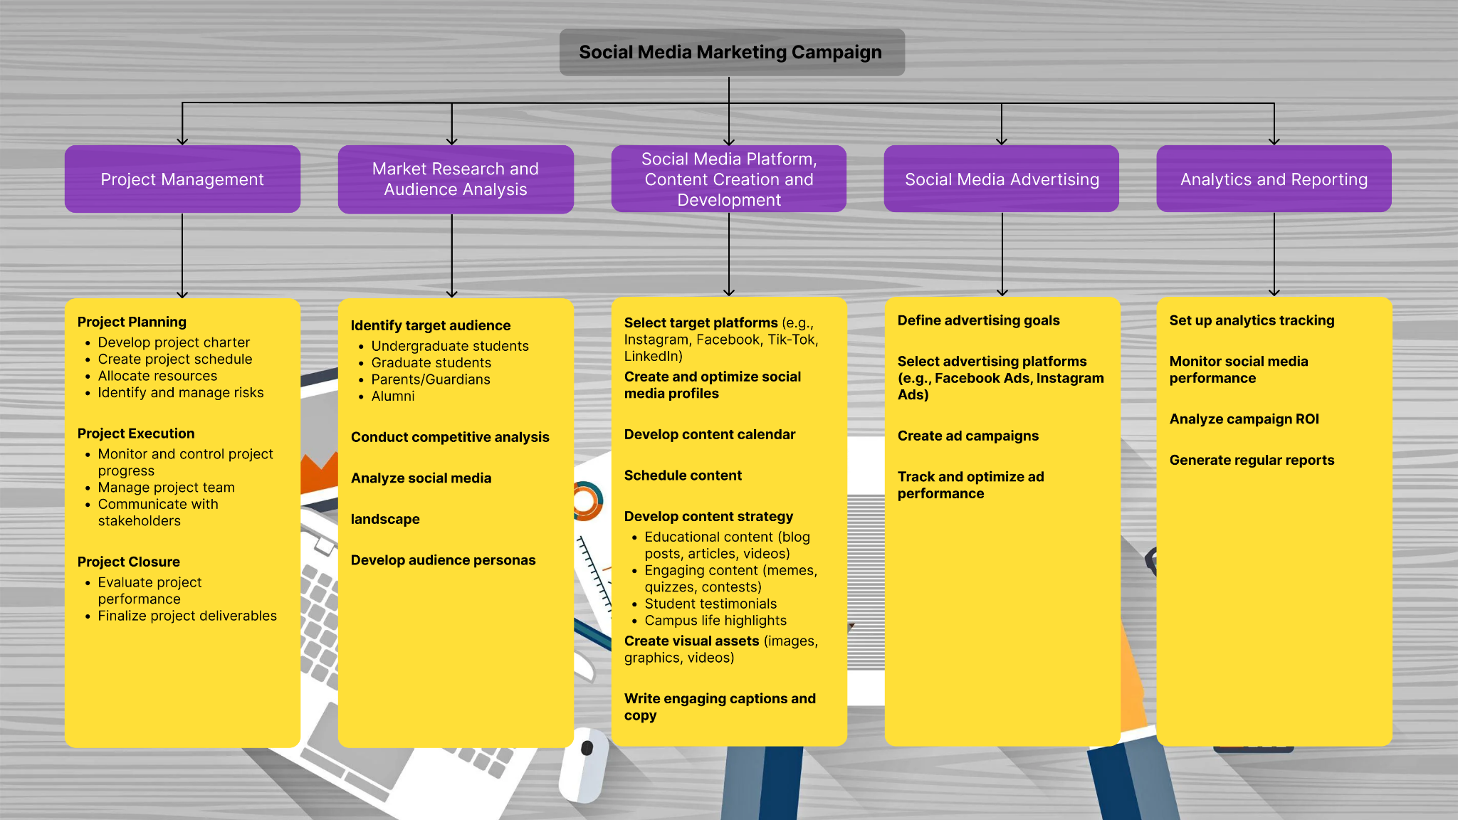

**Work Breakdown of tasks involved in a social media marketing campaign:**

**Project Management:** This encompasses the planning, execution, and closure of the project, ensuring it stays on track and delivers the desired outcomes.

**Market Research and Audience Analysis:** This phase focuses on understanding the target audience, conducting competitive analysis, and analyzing the social media landscape to inform the campaign strategy.

**Social Media Platform Selection and Content Creation and Development:** This involves choosing the right social media platforms, creating engaging content, and developing a content calendar to maintain a consistent presence.

**Social Media Advertising:** This focuses on defining advertising goals, selecting platforms, creating ad campaigns, and tracking their performance.

**Analytics and Reporting:** This involves setting up analytics tracking, monitoring performance, analyzing return on investment (ROI), and generating regular reports to measure campaign effectiveness.